AASRA Funding Request Submission Requirements
This document is to provide members with assistance in understanding what information is required when applying for funding. Much of this funding, especially for participation in major events will come from our casino account which is regulated by AGLC. AASRA has to present a number of documents to obtain permission for the use of these funds.
Please remember that the Sports Director is a volunteer, all requests have to be checked to ensure the information is correct. They are here to help and assist if there are questions.
It is the member’s responsibility to provide the information required. Incomplete funding applications cause delays in getting approval from the AGLC.
Please copy and paste all your screen shots into one document, either a Word or Rich Text File that support images. Please use only screen shots from your computer, no pictures of computer screens will be accepted. All documents are required to be kept for audit purposes and having one document with all information assists AASRA in record keeping. The AGLC is a government agency and as such records can and are audited.
There are a number of was to take a screen shot on your PC. Most people have Windows 10 now. There is an application called Snip & Sketch or Snipping Tool. You may use this app to draw a window around the info you wish to capture. It is then placed inside the app window.
You also able to capture the entire screen on your PC by pressing the Windows key + shift + S
This will not open the sniping tool but place the screen shot into your clip board on your PC where it can be pasted into a document. Using the app will allow you to save the screen captures as images for later use.
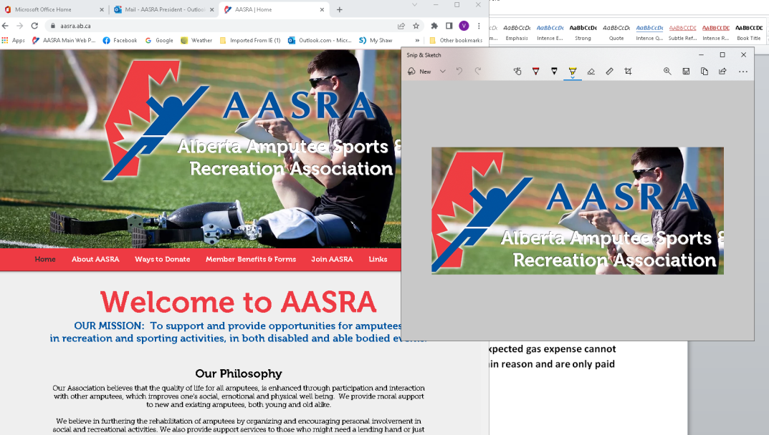
Members are asked to provide screen shots that contain specific information that is required by the AGLC when applying to for the use of casino funds:
1: For travel costs, members may apply for airfare, baggage fees, airport parking, and gas to and from the airport. Car rental is allowed if required. Any insurance, gas or additional charges are at the member’s expense. The use of Uber or ride sharing is strongly encouraged if it is available. It does provide a less expensive and most times a more convenient alternative as the member doesn’t have to pay for insurance and gas.
Members are to provide a screen shot of airfare based on the lowest airfare available. If a member decides to drive to an event, the maximum amount of expected gas expense cannot exceed the lowest airfare available. Gas estimates should be within reason and are only paid with valid gas receipts.
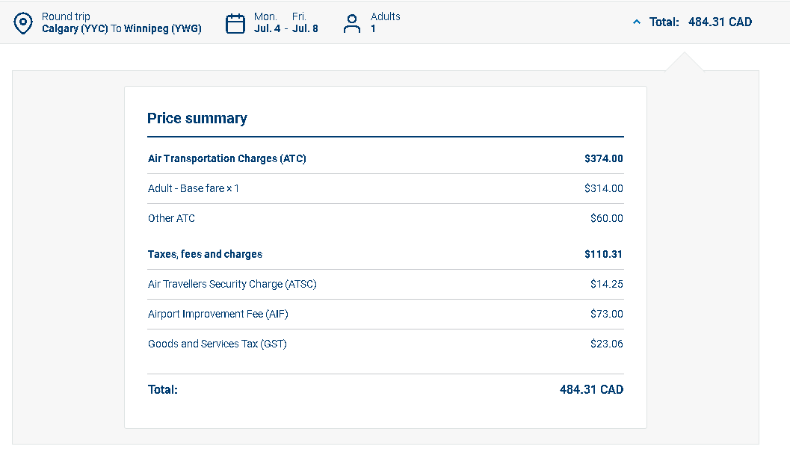
Baggage Fees screen shot:
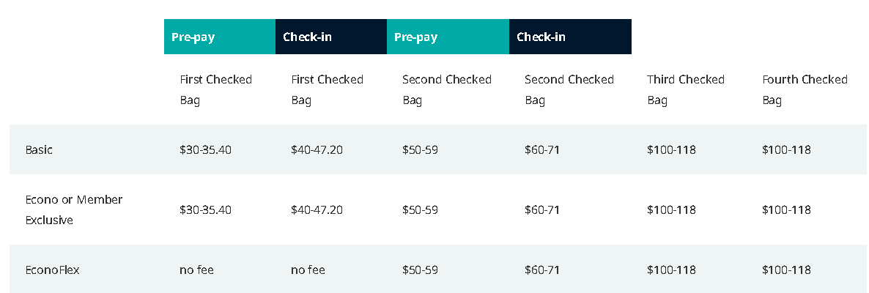
Rental car charges screen shot if required.
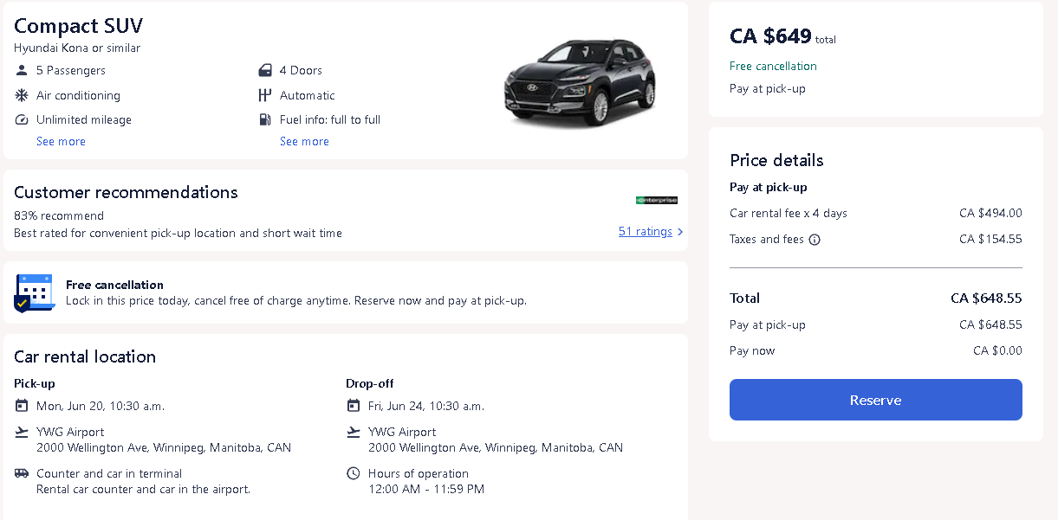
Airport Parking:
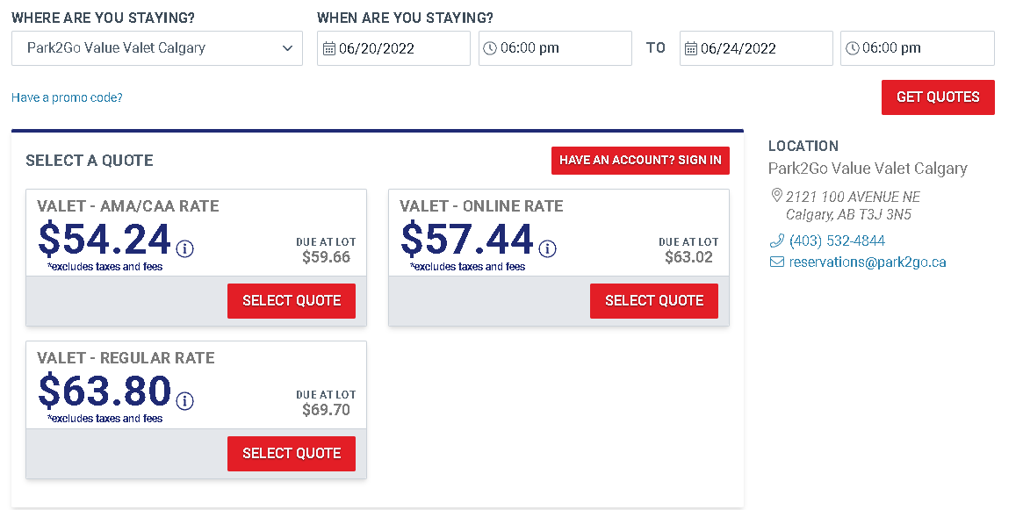

All these items can be listed on your funding request form. They will create a total amount that will be used on the AGLC form that is submitted.
2: The AGLC will require a screen shot with details of the event such as an invitation letter or an outline of the event. A number of events are using online registration; please provide as much information possible in your request.
Also the AGLC likes to see a webpage link provided.
https://www.golfgenius.com/pages/7937716955094501395

3: The AGLC requires a schedule of events. Please use a screen shot from the event web page.
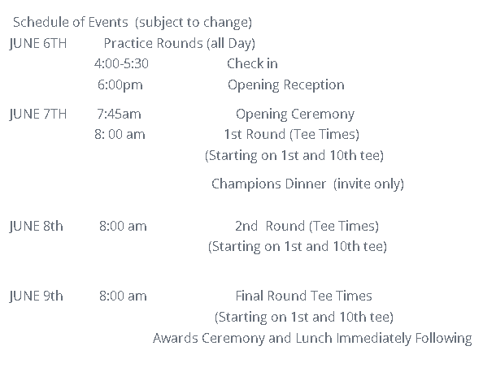
4: Registration Fees: A screen shot is required of the registration fees and must also include a breakdown of what those fees include if these fees include items such as meals.
Cost of meals or any other benefits must be removed from the registration fee listed on your funding form.
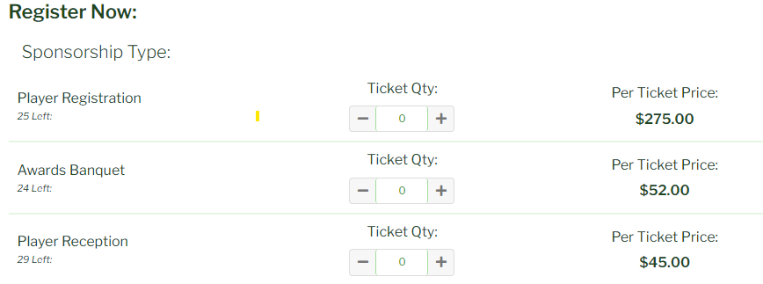
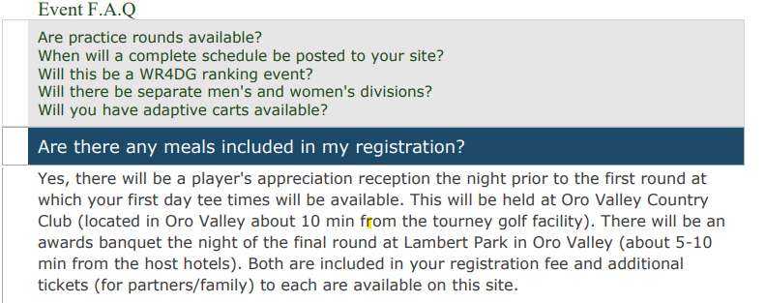

5: Accommodations: If your planning on using a host hotel with special rates that are listed with the event, please provided that information in a screen shot. If you staying at outside accommodations please provide a screen shot of the reservation including room cost and taxes. Members are allowed to arrive one day in advance of any event where long travel is required such as flights.
Our host hotel facilities for these events will be the El Conquistador Resort by Hilton and The Westward Look by Wyndham both located within 20 minutes of the golf facilities.

Westward Look Resort Wyndham Grand Resort and Spa
Rate Guarantee: $119 per night (single/double occupancy)
Available booking dates: 4/8/2022 through 4/16/2022
Reservation cutoff date: 3/21/2022 @ 5:00 pm MST
Check-in 4:00 pm. Check-out 11:00 am.
Rates are subject to state and local taxes, which are currently 14.55% and reduced daily resort charge of $15 Reservation by phone: 1-520-917-2970

Meals: AASRA will allow members to apply for meal expenses up to $45 a day. Receipts are required and no alcohol will be covered and tips are a member’s expense.

Please see an example below of a completed funding request.
Alberta Amputee Sports and Recreation Association - Funding Application

Submit Funding Applications to: Attn: Sports Director at info@aasra.ab.ca or mail to:
AASRA, P.O. Box 86093 Marda Loop RPO, Calgary, AB T2T 6B7

Please complete a separate form for each event or competition

Name: | AASRA Member | Date: | Jan 01 0000
Address: | Members Address | Postal Code: |  | XXX XXX
 |  | Phone #: |  | XXX-XXX-XXXX
 |  | Cell #:
Email Address: Members Email
Name of Competition: |  | Date(s):
0000 Event Name |  | Jan 01 – 05 0000
Location of Competition: City, Prov\ State
Facility Hosting Event, Golf Course, Rink, Sports Complex or Field
Transportation: (airfare, rental car, mileage): |  | $1200.00
Airfare From City to City Return $500.00
Baggage Fees $80 X 2 = $160.00
Rental Car $420.00
Airport Parking $80
Gas to Airport $40
Accommodation: Name of Hotel |  | $504.00
Your Hotel $120.00 X 4 = $480.00
Taxes $480.00 X 5% = $24.00 Total = $504.00
Registration: Event Registration $200.00  Minus $50 in supplied meals = $150.00 |  | $ 150.00
Subtotal |  | $1854.00
Other Expenses
Meals 4 X $45 = $180.00 |  | $180.00
TOTAL |  | $2034.00

Funding From Other Sources : Yes □ No X
Sports Director:
Treasurer:
Cheque #:

Please provide as much information as possible with your request including quotes, event information, sanctioning organization (invitation) information. The information on this form is used as an estimate of the costs as well as justification for funding. Please obtain current costs for flights and accommodation.
If you are receiving funding from another organization to help cover a portion of your costs, this must be noted on the form.
Funding will only be available upon notification of approval from AASRA (Sports Director). Until that time all costs will be considered the responsibility of the AASRA member.
Submit Funding Applications to info@aasra.ab.ca or mail to:
AASRA,
P.O. Box 86093 Marda Loop RPO,
Calgary, AB
T2T 6B7
ATTN: Sports Director
If your event is in another country and expenses are paid in a different currency, you can convert the amounts on your form. If your registration in US dollars then you can list the amount paid in US currency and then multiplies by the exchange rate. Use CND amounts as a final total on your form.
Registration: Event Registration $200.00
Minus $50 in supplied meals = $150.00 US X $1.30 = $195.00 CND
After your submitted funding request is received it will be presented to the Board of Directors. The request will then be filed with the AGLC for approval. The Sports Director will then inform the member of the results.
After the completion of your event the member is required to fill in an AASRA Reimbursement Form. The form can be found on the AASRA website at https://www.aasra.ab.ca/aasra-forms
There you will provide details of your expenses, this form as well as scanned copies of your receipts can be emailed to the Sports Director at Sportsdir@aasra.ab.ca
You may also mail receipts to the address listed on the form.

